СODE PUBLISHING INSTRUCTION

IF THIS IS YOUR FIRST TIME)

CHECK GULP

- Check if Gulp is installed on your computer. Type in command line
gulp –version
If it is not installed, then follow the instructions on the link till "Install the gulp command line utility". Also, you can follow any video on YouTube.
https://gulpjs.com/docs/en/getting-started/quick-start/

PREPARING CODE FOR PUBLICATION

INCLUDE DIST FOLDER

In the course of work this folder should be excluded from the project. Before you start publishing code, you need to include it in the process. After the publication process is completed, it must be excluded.
If the folder is drawn with a dotted line, it means it is not included in the project.
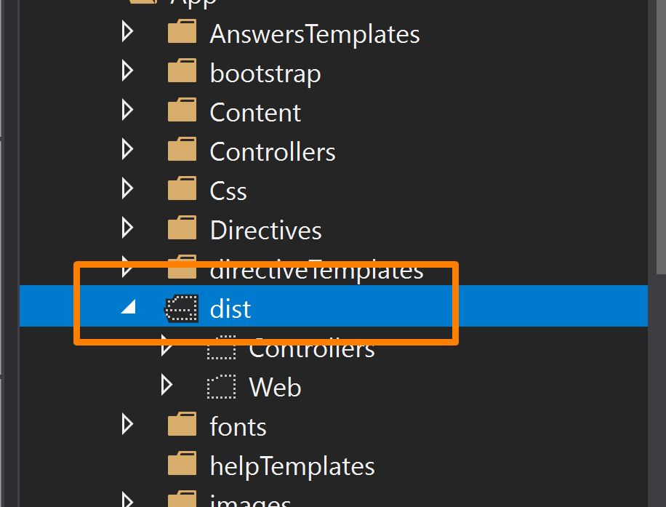
- In Solution Explorer Right click on the folder and choose Include In Project
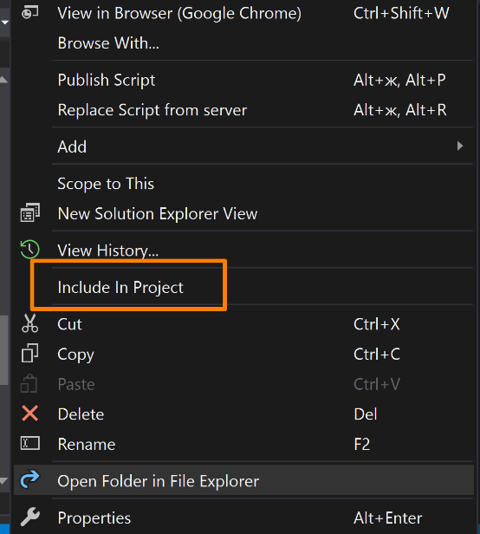

RUN GULP

Gulp will run several plugins, for example:
Babel - convert ES6+ code into a backwards compatible version of JavaScript that can be run by older JavaScript engines.
Uglify - JavaScript parser, minifier, compressor and beautifier toolkit.
All modified files will be written to the dist folder
- In the command line open the project folder: cd [folder path]
- run gulp

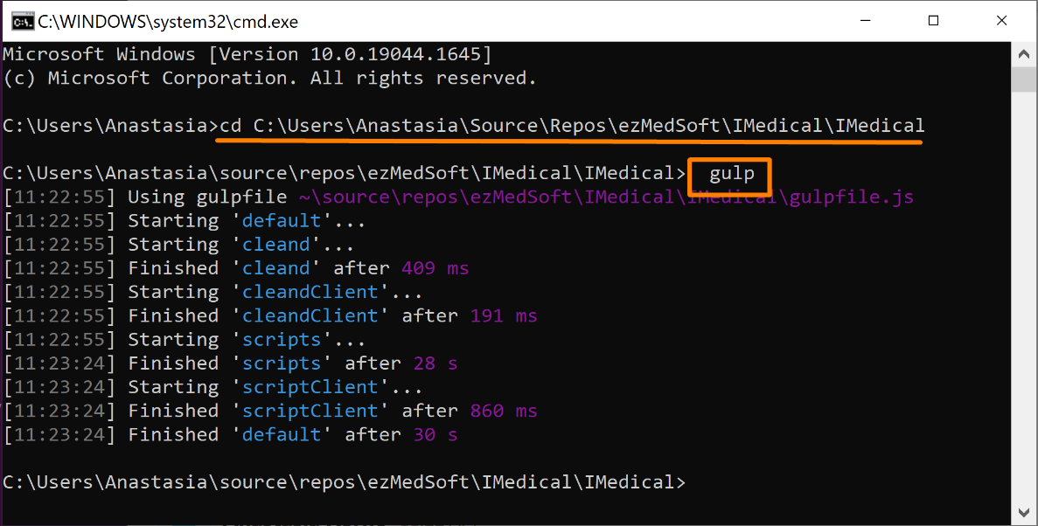

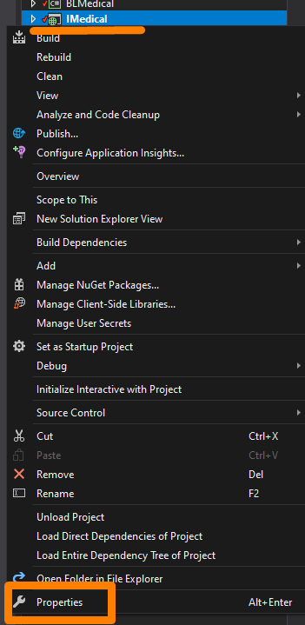
UPDATE PROJECT VERSION

- In Solution Explorer right click on IMedical.
- In the window that appears, select Properties.
- In the window that appears,
click the button Assembly Information.
- In window Assembly Information increase by 1 the last field Assembly version and File version.
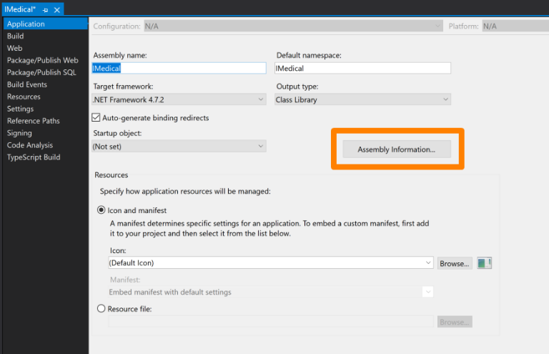

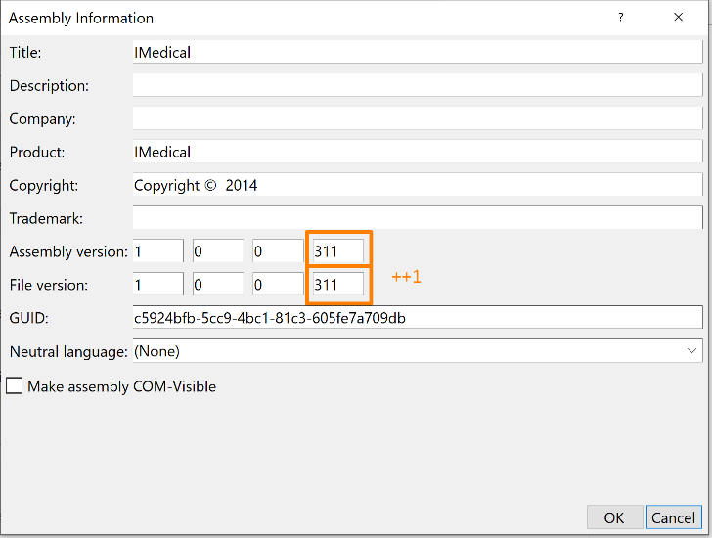

CHANGE INDEXTAMPLATE.TXT

After the project is submitted to the server, when it is launched, the Global.asax.cs file will be launched. Because of this, the index.html file that we modified in the development environment will be overwritten on the server according to the indexTamplate.txt file.
This allows us to overwrite the file paths and the server will read files from the dist folder that we have previously modified with gulp.
Because of this, it is necessary to manually update the indexTamplate.txt accordingly Index.html. Please copy the sample writing from other lines inside this file.

index.html | indexTamplate.txt
<script  src="Web/DoctorsDiary/DoctorsDiaryCtrl.js">  </script> | <script  src="Web/DoctorsDiary/DoctorsDiaryCtrl.js?ver=">  </script>

PUBLISH
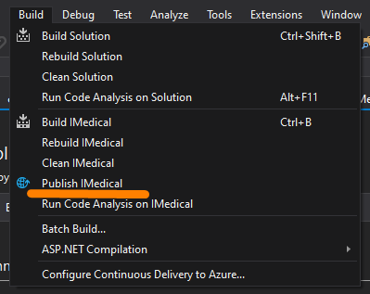
- In the top menu, click on Build.
- In the list that appears, select Publish IMedical.
- Choose your folder or create new.
- Click the button Publish.
- Copy the generated files.

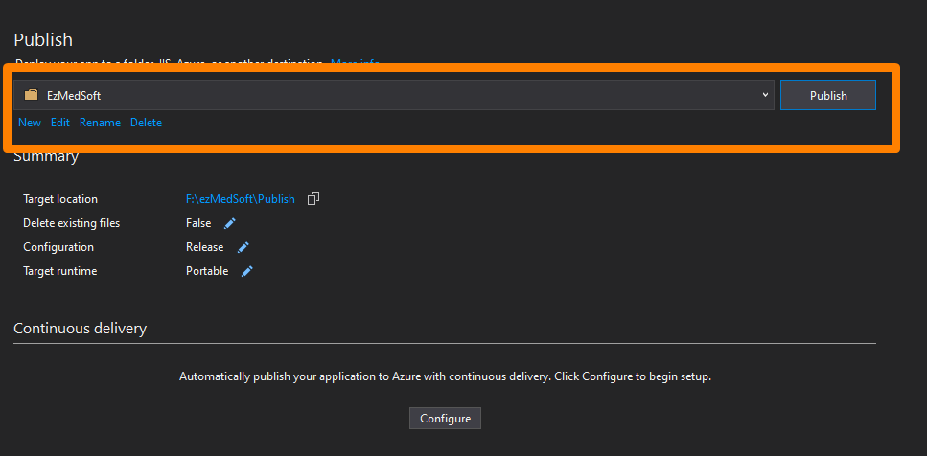
- log in to the server you want.
- Open IIS.
- Right click on the site.
- Choose Explore
- Paste the previously copied files into the opened folder
- Return to IIS in the right pane, click on the restart button.
- Launch the site through the link in the right window
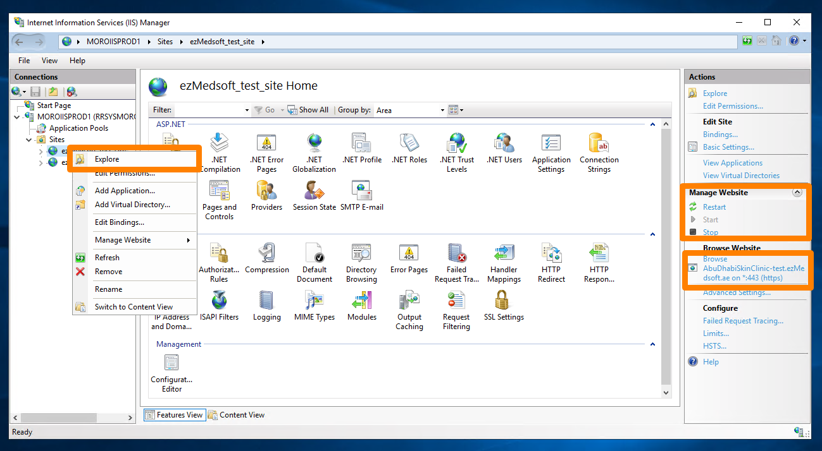

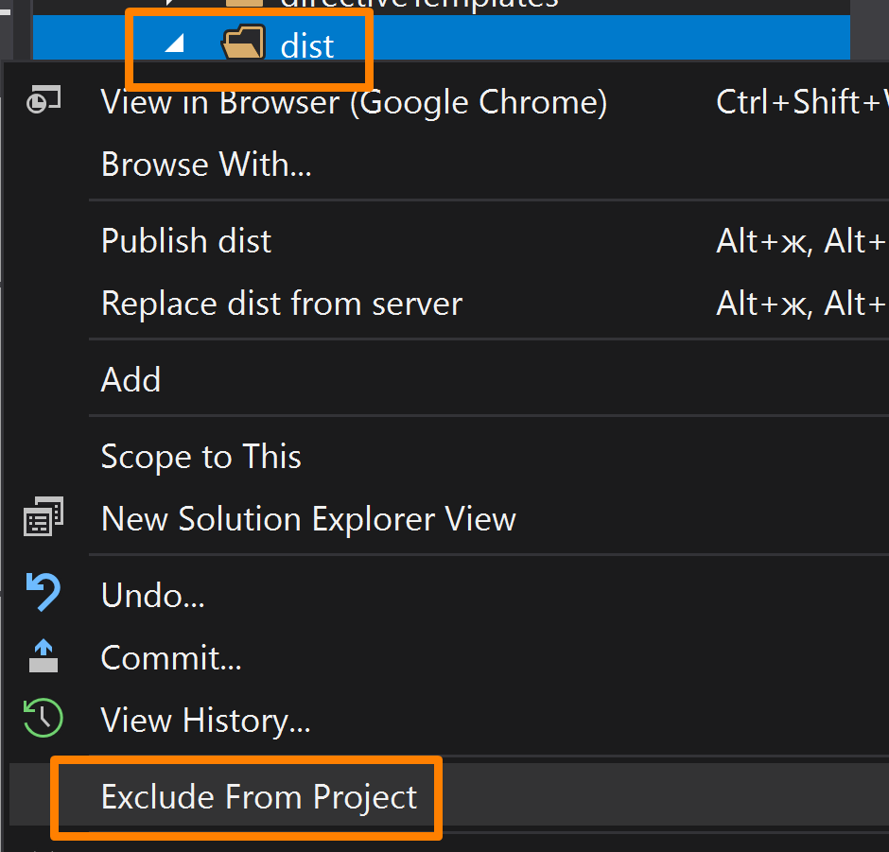

EXCLUDE DIST FOLDER

Then exclude dist folder from the project. This folder should be always excluded from the project.
- Right click on the dist folder.
- In the window that appears, select Exclude From Project.

